Unit 1 ~ Learning Guide Name:
Instruction
Using a pencil, complete the following notes as you work through the related lessons. Show ALL work as is explained in the lessons. You are required to have this package completed BEFORE you write your unit test. Do your best and ask questions if you don’t understand anything!

Math in Physics: Solution
- Convert the following to scientific notation in standard form a) 34674 = 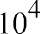
b) .000235
c) -2300000 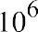
d) -0.0000150
e) 0.00750
2. Indicate the number of significant figures in the number given

- a. 120000 _2__
- b. 32100.0 _6__
- c. 0.00123 _3__
- d. 0.20040 _5__
- e. 730.01 _5__
- f. 0.0300 _3__
- g. 7.590x10³ _3__
- h. 9x10⁻⁴ _1__
- Evaluate the following and use the correct number of significant figures in your answer (Show all work)
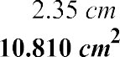
a).

b). = 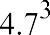
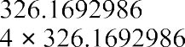

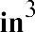
(since the units are raised to power 3 then the units of the answer should
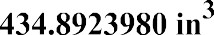
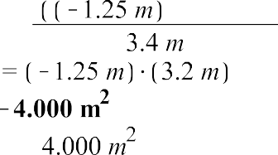
c).
=

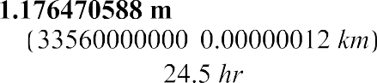
d).
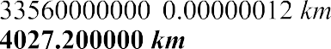

/hr.
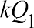
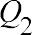
- Rearrange the equation, solving for the variable shown (clearly show all steps). a). Solve for where
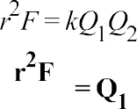
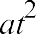
- Solve for t where

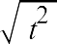

- Solve for v , where

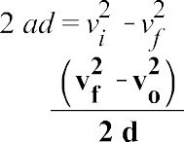
- Solve for a where

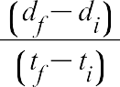
- Solve for where
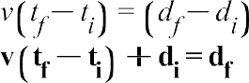
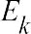
- Solve for m where


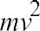
- solve for m where

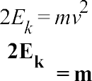

- Solve for where
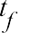
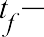
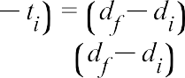
=

=
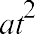
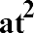
- Solve for where
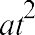
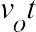

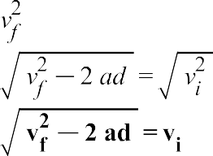
- Solve for where
=
- Solve for where

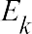
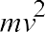
- Solve for v where
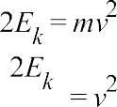

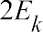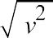


- Solve for t where
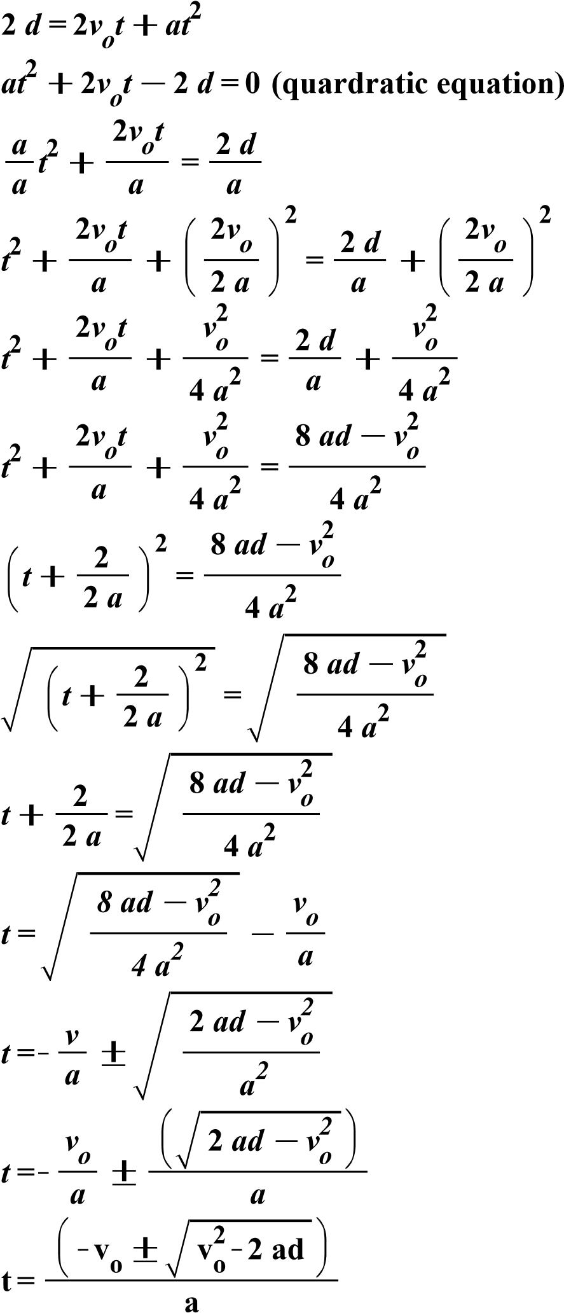

5). Solve for the following triangles using SOHCAHTOA and Pythagoras. show working a). solve for x,y, and A

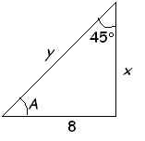
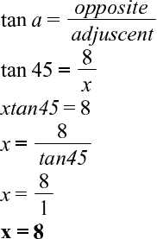

Pythagoras theorem
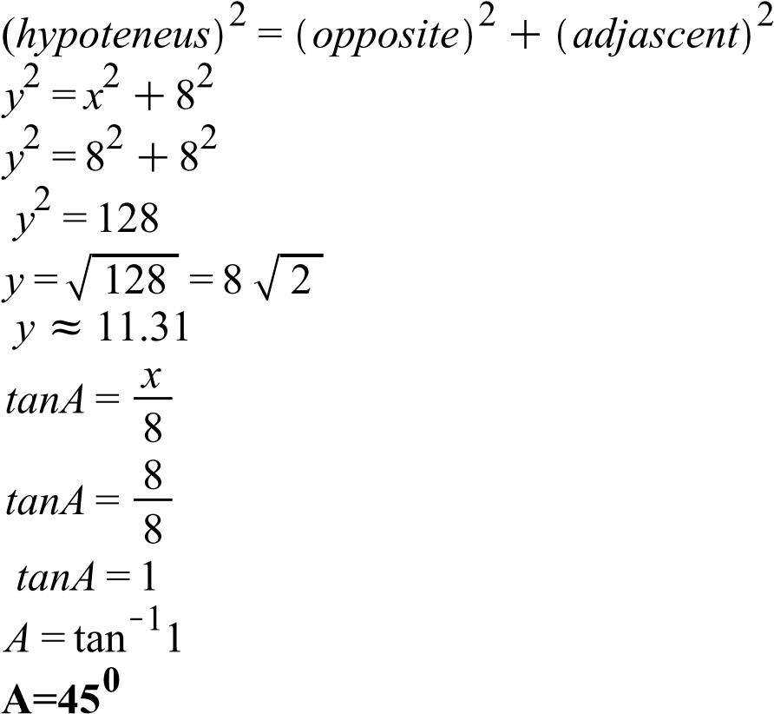

- Solve for R and Ø
Using Pythagoras theorem,

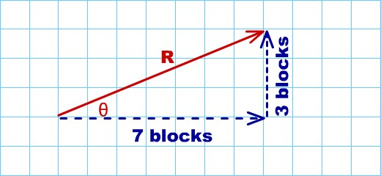

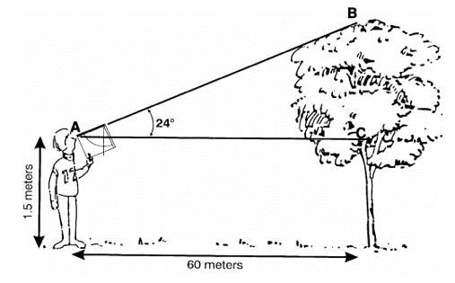
- Solve for BC and total height
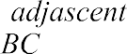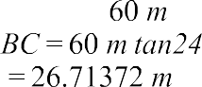
Total height
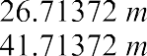
=
=

a). 2.67 hours into seconds multiply by 3600sec/hr.

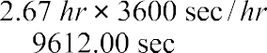
=
- 80 km/hr. to m/s
multiply 1000mhrs/3600kmsec
=
- 34 km into meters multiply by 1000m/km
=
- 1 day into seconds
step1: multiply by 24hr/day to convert days to hours
=
step 2: multiply by 3600sec/hr. to covert hours into seconds
=
- 12 hours into seconds multiply by 3600sec/hr.
=
- 100 km/hr. into m/s
multiply 1000mhrs/3600kmsec
=
- 40 km/hr. into m/s
multiply 1000mhrs/3600kmsec
=
- 12 m/s into km/hr.
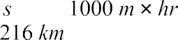
multiply by 3600kmsec/1000mhrs
=
- 200 g into kg
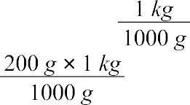
multiply by
= kg
5
- 10 kg into grams multiply by 1000g/kg

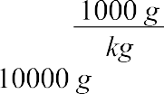
=
- Suppose that the water level of a river is 34 meters and that it is receding at a rate of 0.5 meters per day. Write an equation for the water level, L, after d days. In how many days will the water level be 26 meters? (include units for everything)
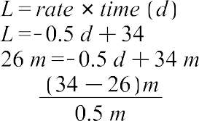
- A plumber charges $25 for a service call plus $50 per hour of service. Write an equation in
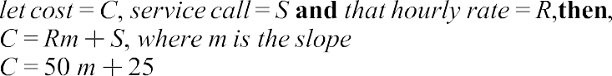
slope-intercept form for the cost, C, after h hours of service. (include units for everything)
- A runner gets a 30meter head-start then runs 5 km/hr. Write an equation (in base SI units) which will represent the runners distance from the start line at any second. (include units)
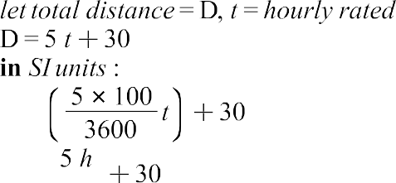
- A car begins at a speed of 20 m/s then increases its speed by 2.0 m/s each second. Write an equation that represents the speed of the car as a function of time. (include units)
let v=speed, t=time taken for acceleration

Kinematics Review:
- The acceleration of a freely falling object (near Earth), when we assume no air resistance, is
(remember units). This acceleration (due to gravity) is also called the gravitation constant and is represented by the letter g.
- The assumption of no air resistance is never totally true, but is often close enough to make pretty accurate calculations. Discuss cases where this is really good assumption and when it isn’t
An example of a free fall is that of a spacecraft in continuous orbit. The free fall would end once the propulsion devices turned on.
- As difficult as it is to visualize the changes in velocity, a good understanding of acceleration is needed to master kinematics problems. Recognizing that acceleration can be positive, while velocity is positive (and visa) is definitely brain exercise.
  - Object is speeding up (from still) in the positive direction. For example, a ball is placed on a slanted ramp.
Velocity is positive and increasing Acceleration is positive.
  - Object is speeding up (from still) in the negative direction. For example, a ball is placed on a ramp that is slanted towards the negative direction (eg. down to the left).
Velocity is negative and decreasing. Acceleration is negative.
  - Object is slowing down in the positive direction. For example, you push a ball up a slanted ramp.
Velocity is positive and decreasing. Acceleration is negative.
  - Object is slowing down in the negative direction. For example, you push a ball up a ramp that is slanted towards the negative direction (eg. down to the right).
Velocity is negative and increasing. Acceleration is positive.
- Review your results from the previous question to build general statements that are always true:

Acceleration is always in the opposite direction of velocity if the object is slowing down. Acceleration is always in the same direction of velocity if the object is speeding up.
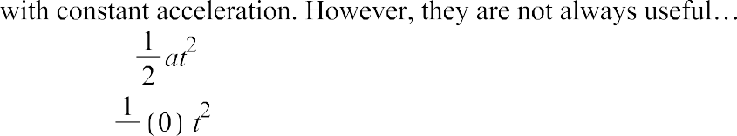
- Show what happens to each of the following kinematic equations when the acceleration is zero (a=0). Once you have simplified, interpret, in words, what the equation is telling us. Keep in mind that the kinematic equations are always valid for motion
i.
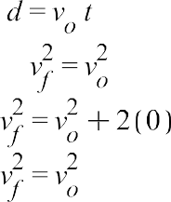
ii.
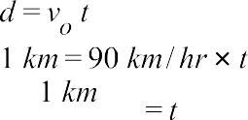
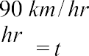
- A stationary boat accelerates to 90 km/hr over 1 km. What is the time it takes to do this?

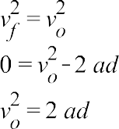
- A braking train can decelerate at . If the train is travelling at 160 km/hr and needs to plan to stop at a pick-up area. How far in advance does it need to apply the brakes?

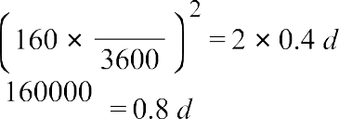
- A satellite in space is travelling at 14 m/s in one direction. A thruster is applied for 30 s and the satellite is then travelling at 12 m/s in the opposite direction. What acceleration does the thrust cause?
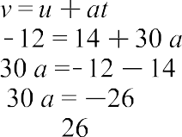

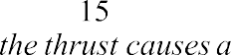
- A rock is dropped off a 40meter cliff. The rock accelerates due to gravity. What is the time it takes to hit the ground?

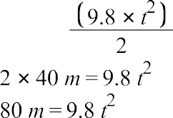

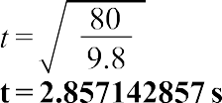
- A motorcycle is travelling at a constant velocity of 90 km/h (no acceleration). How many seconds will it take the motorcycle to cover 2 km?

=
- Hikers at the bottom of a canyon are facing towards the canyon wall 280.5 meters away. Given that the speed of sound in air is 340 m/s, how long after they should will they hear their echo?

the time taken to hear the echo will be twice the time of the time taken by the sound to reach the canyon therefore

- A child on a toboggan slides down a snowy hill, accelerating uniformly at . When the toboggan passes the first observer, it is travelling with a speed of 1.4 m/s. How fast will it be moving when it passes a second observer, who is 2.5 m downhill from the first observer? Show all work as demonstrated in the lessons.
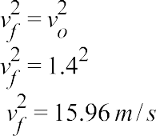
- A semi-loaded train travelling at 100 m/s can decelerate at . How far in advance must the brakes be applied to come to a stop?

19m. What is the initial velocity of the bike?

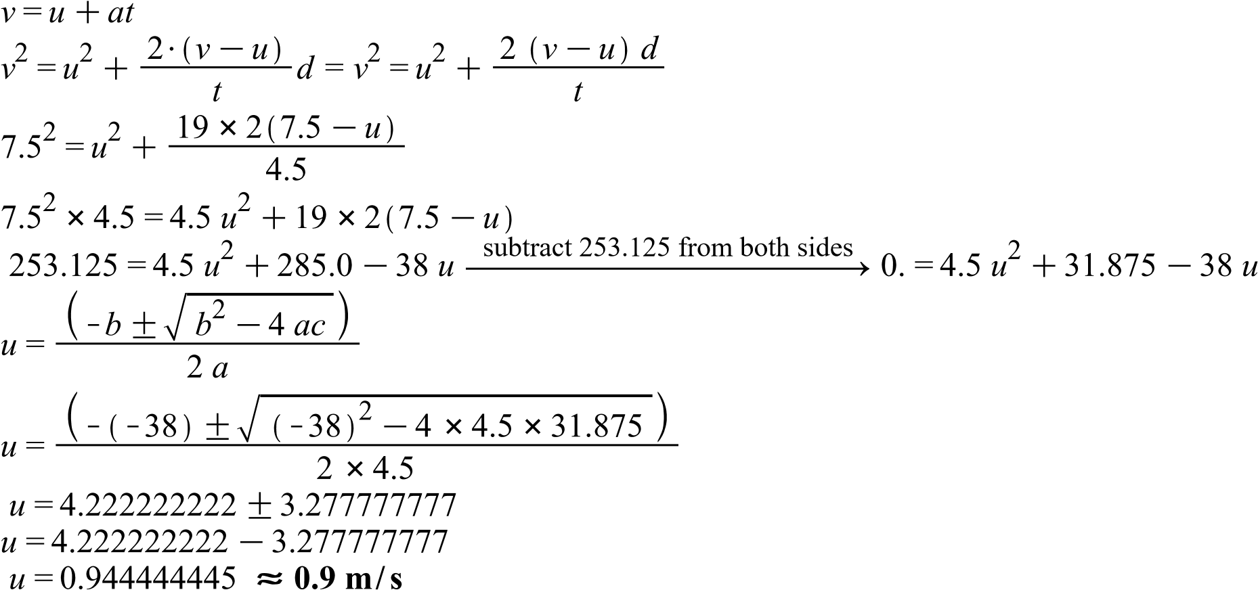

- A cyclist moving with constant velocity of 6.0 m/s forward passes a car that is just starting. If the car has constant acceleration of 2.0 m/s2, where and when will the car overtake the cyclist (ie.
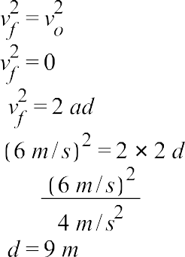
they are both the same distance from the starting point)? Show all work as demonstrated in the lessons.

- A stone is dropped from the top of a tall building. It accelerates at a rate of . How long will the stone take to pass a window that is 2.0 m high, if the top of the window is 20.0 m below
the point from which the stone was dropped? HINT: draw a picture for starters. Show all work as demonstrated in the lessons.

17). Provide a description of a sample situation for each of the graphs below (make sure to recognize each graph as d vs t, v vs t, or a vs t).
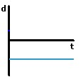 | A particle is at rest | 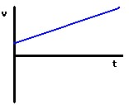 | A particle moving with an increasing acceleration
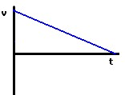 | A particle moving with a decreasing acceleration | 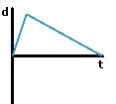 | A particle accelerating up to a certain point at which it the decelerate
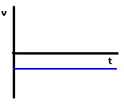 | The particle has zero acceleration therefore it’s not moving | 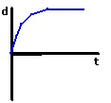 | At first a particles velocity increases with an increasing velocity then increases with a decreasing velocity and finally move with a constant velocity.
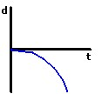 | The body is in non-uniform increasing negative velocity | 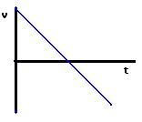 | The body decreases its velocity until it reaches negative velocity
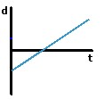 | The motion of the body start from the negative velocity to positive velocity | 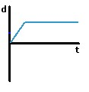 | The object is in motion for a while then comes to rest
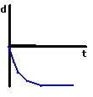 | The body is in non-uniform decreasing negative velocity | 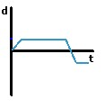 | The body is in increasing velocity then comes to rest before it decelerates to negative velocity then to rest.
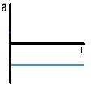 | The body is at rest | 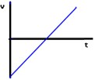 | The body is accelerating from the negative to positive acceleration

- Sketch the basic graph shapes (and add values where appropriate) for the various projectile problems. Some have been done for you – make sure you understand them.
 | Type 1 | Type 2 | Type 3
Example  Situation  (canon) | 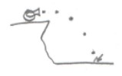 | 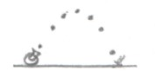 | 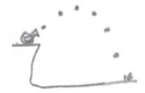
special | V_{yo} = _____ | d_{y} = ____ | V_{yo} ≠ ___, d_{y} ≠____
d_{x} vs t | 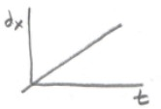
d_{y} vs t |  | 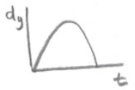
v_{x} vs t |  |  | 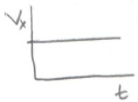
v_{y} vs t | 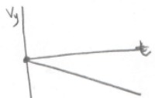
a_{x} vs t |  | 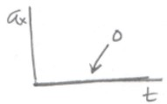
a_{y} vs t | a_{y}  +9.8  t |  | 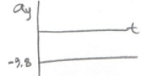

VECTORS:
Vectors:
- Convert the following into vertical and horizontal components. Show all steps and include units. a) horizontal components
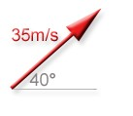
cos a=adjacent/hypotenuse
Cos 40=adj/35 Adj=35cos 40
= 26.81m/s
Vertical components Sin a= opposite / hypotenuse
Sin 40=opp/35 35sin 40= opp
=22.5m/s
- horizontal component cos a=adjacent/hypotenuse
Cos 74=adj/1.2
Adj= 1.2cos 74
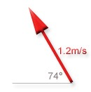
= 0.33m/s Vertical components
Sin a= opposite / hypotenuse Sin 74=opp/1.2
1.2sin 74= opp
= 1.15m/s
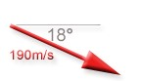
- horizontal component cos a=adjacent/hypotenuse
Cos 18=adj/190
Adj= 190cos 18
=180.7m/s
Vertical components
Sin a= opposite / hypotenuse Sin 18=opp/190
190sin 18= opp
= 58.71m/s
- Break the following vectors into components (remember directions) - show work by sketching each vector, labeling the angle and showing components!
- 25 [35º N of E] Horizontal component
cos a=adjacent/hypotenuse cos35=adj/25 25cos35=adj

X=20.5 E
Vertical components
Sin a= opposite / hypotenuse
Sin 35=opp/25 25sin 35= opp

Y= 14.3 N
- 373 [12º E of N] Horizontal component
cos a=adjacent/hypotenuse cos12=adj/373 373cos12=adj

X= 364.8E
Vertical components
Sin a= opposite / hypotenuse Sin 12=opp/373
373sin 12= opp

Y= 77.6N
- 126 [22º N of W] Horizontal component
cos a=adjacent/hypotenuse cos22=adj/126 126cos22=adj

X= 116.8W
Vertical components
Sin a= opposite / hypotenuse Sin 22=opp/126
126sin 22= opp

Y= 47.2N

3. Add the following vectors together using the component method.
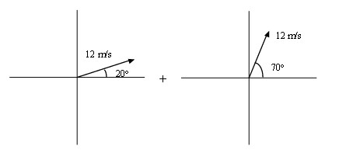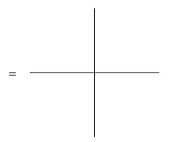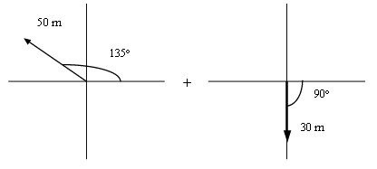
a.

Sketch Resultant

X
₁

____11.28_________ + X
=
₂

____11.28__________
=

X
_{tot}
=

__1.78___________

Y
₁

____4.1____________ + Y
=
₂

=
____4.1_____________

Y
_{tot}
__8.21___________
=

Magnitude
of Resultant
(
hypothenuse
)

R = _8.21m/s____________

Direction

of Resultant (find
angle)

Ө

=
__90⁰ N of E___________

b.

Sketch Resultant

X
₁

=
__-35.36___________ + X
₂

=
__1.84_____________

X
_{tot}
=
_-35.36_________

Y
₁

=
__35.36____________ + Y
₂

=
__-30_______________

Y
_{tot}
_5.36___________
=

Magnitude
of Resultant
(
hypothenuse)

R = _35.76m/s__________

Direction

of Resultant (find
angle)

Ө

=
___8.6⁰ N of W_________

overall displacement? Use the trig method (i.e. The sine and cosine laws)
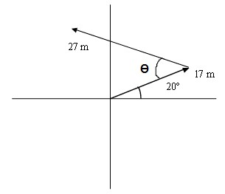

- Determine the angle, as shown above (it often helps to draw another x-y axis at
the start (tail) of the second vector)
Draw in the resultant and label it R. Be sure to draw in the arrowhead to show its direction

27m

R

17m

20⁰

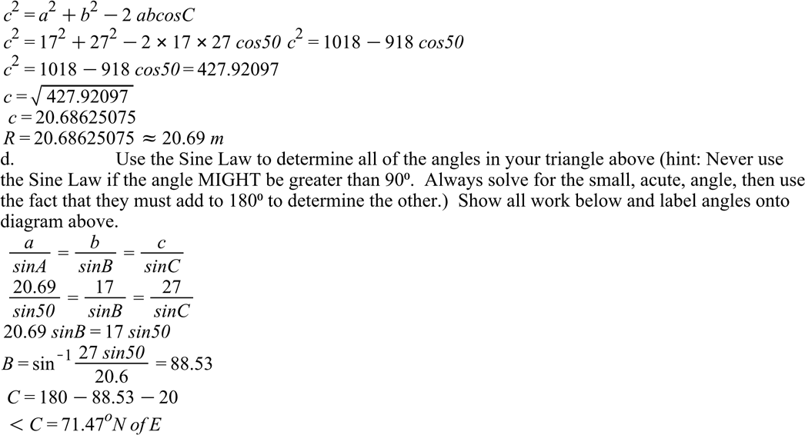

- To properly specify the final direction of your resultant above, you need to provide an
angle that is referenced to either the horizontal axis (x-axis) or the vertical axis (y-axis). Determine the final direction N of W that your resultant is pointing (find the angle between R and the negative x-axis).

- Can three parallel vectors unequal in magnitude add to zero? Show with a vector diagram below.
Yes
a

b

c
a+b+c=0
- Can three vectors of different magnitudes and directions add to zero? Show with a vector diagram below.
Yes

a

d b

c

a+b+c+d=0
- The kinematic equation d = vt is used in conjunction with relative velocity questions. Explain why the other kinematic equations are not useful for most relative velocity questions.
Multiple questions on relative velocity assume that acceleration is 0 (constant velocity) and therefore the kinematic equation d = Vt is the most appropriate.

- Two swimmers of identical ability want to race across a river. The goal is to touch the other side first (anywhere along the bank). Both swimmers can swim at a rate of 5m/s in still water. The
river along a line perpendicular to the point on the shore where she started. Swimmer B points directly
- Which swimmer makes it across first? Why do you think this is so?
swimmer B will reach the other side of the river before swimmer A. this is because swimmer A is swimming against the water current which therfore reduces his or her swimming speed.

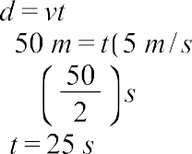
- If the river is 50m wide determine the time it takes for each swimmer to cross. swimmer A

Swimmer B
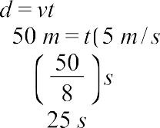
- Using swimmer B above solve for the following: Construct the equivalent displacement vector diagram and label all sides and angles with correct values. Use the equation d = vt and solve for t in each direction (i.e. time to travel downstream, time to travel diagonally).
Sin Ø=3/5
Ø= sin⁻¹ 3/5= 36.87º
90-36.87º=53.13º

Direction of the river bank 5m
36.87º
Swimmer B
5m/s
Speed and direction of the river 3m/s

53.13º

- How far downstream does Swimmer B end up?

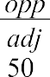
.

9. An airplane travels with an airspeed of 400 km/h NE (in still air). Wind blows from the North at 50km/h.

- Break down both given velocities into components. Draw the original vectors roughly to scale and label the values of the x-y components directly on the sketch

400km/h

50km/h

- What component does wind affect? How does this affect the overall airspeed as seen from an observer on the ground? Remember ‘’speed’’ is scalar, I am really asking if the plane speeds up or slows down overall.
The wind velocity affects the horizontal components. The speed of the plane will slow down due to this effect.
- What is the final velocity as seen from the ground? We call this vg for velocity with
respect to ground.

10. Repeat the above question with the airspeed initially at 400km/h NW. This time the plane ENDS UP flying at 300 km/h 30º N of W.
- What do we call the 300 km/h velocity that the plane ends up at? (refer to previous question)
Resultant velocity

- Break down each of the given vectors into components. Draw and label scaled diagrams as you did in the previous question.

400km/h

30º

300 km/h

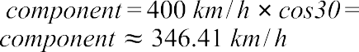

- How much has the plane’s resulting velocity changed in the x (E – W direction) from the
previous problem? What caused this change?
The velocity changed because the angle at which the plane was flying at is much directed against the speed of the weed as opposed to the earlier case.

- How much has the plane’s resulting velocity changed in the y (N – S direction) from the previous question? What caused this change?
The velocity changed because the angle at which the plane was flying at is much directed against the speed of the weed as opposed to the earlier case.
- Using your results above what are the wind’s components? What is the overall wind velocity?

- A jet aircraft is aimed south and travelling 851 km/h. A wind blows the plane toward the east at
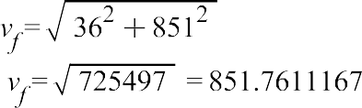
36.0 km/h. What is its resultant velocity? using Pythagoras theorem
using tangent
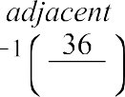

Projectiles:
- Describe (in your own words) what a projectile is. Provide examples.
A projectile motion is the motion of a protected object in the air. The projected object is known as a projectile. For example, a stone thrown from point A to B through the air.
- What is the biggest difference in a projectile’s horizontal and vertical motion? What phenomenon causes this difference?
In horizontal projectile motion, the motion is not changing while in vertical projectile motion, the motion of the object keeps changing. The difference is caused by the effect of gravity on both projectile. The gravity has effect on vertical motion but has no effect on the horizontal motion.
- Summarize the (often) surprising result of shooting a gun and dropping a bullet at the same time. Why is this true (explain in terms of horizontal and vertical components of motion)?
Both the shot and dropped bullet will not land at the same time. The horizontal component of the bullet signifies the displacement of the shot bullet which moves a higher distance as compared to the vertical component. Normally, the vertical and horizontal component of both situations cannot be equal and hence the difference in time of flight.
- Consider the monkey dropping problem from your lessons (i.e. shooting a dropping monkey).
  - Where must you aim the rifle for you to hit the falling monkey? Why?
The aim should be slightly below the monkey. This is because the effect of gravity has effect on both the rifle and the monkey.
  - What if you had a gun with a higher muzzle-velocity? i.e. the bullet reaches the monkey faster. Why?
At a higher height a quicker bullet will reach the monkey while a slower bullet will actually touch the monkey closer to the ground. Since gravity gives both objects the same acceleration, their vertical positions are inextricably linked if the hunter directly targets the monkey
  - Change the height of the monkey to its maximum and repeat. Explain where you must aim the arrow and why it works?
When the monkey is seated on its maximum height, a hunter should aim slightly high. this is because of the force of gravity and air resistance. It works because the air resistance will aid in the downward movement of the arrow.
- You are exploring a newly discovered cave in the Andes in South America. Peering over the edge of a cliff in the cave, you can’t see the bottom. Wondering if you have enough rope to rappel to the
ground, you drop a rock off the top, and hear the sound of it hitting the bottom 4.2 seconds later. Find the height of the cliff ignoring the time that the sound takes to travel back to you from the bottom. Show all work as done in lessons.

- 0.30 s after seeing a puff of smoke rise from the starter’s pistol, the sound of the firing of the pistol is heard by the track timer 100 m away. What is the velocity of sound? Hint: treat the speed of light as instantaneous.

- A boy throws a rock straight up into the air. Explain the changes taking place through the flight in terms of velocity and acceleration.
Generally, the velocity and acceleration of the object is slowing. It is mainly due to the effect of the gravitation force pulling it down towards the ground. At first, the velocity and acceleration increase at an increasing rate due to the force used to throw the rock upwards. However, as the rock move through the air, it experiences the effect of gravity and air friction and therefore increases with a decreasing rate.
Finally, the rock reaches its maximum height where both the velocity and acceleration becomes zero.
- A stone is thrown horizontally at 15 m/s from the top of a cliff 44 meters high.
- How long does the stone take to reach the bottom of the cliff? Show all work as done in lessons.

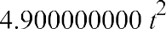

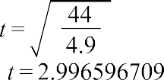
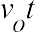
- How far from the base of the cliff does the stone strike the ground? Show all work as done in lessons.

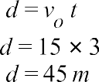
- A golfer hits a ball at a 40degree angle with an initial speed of 35 m/s. How far does it travel before it hits the ground?
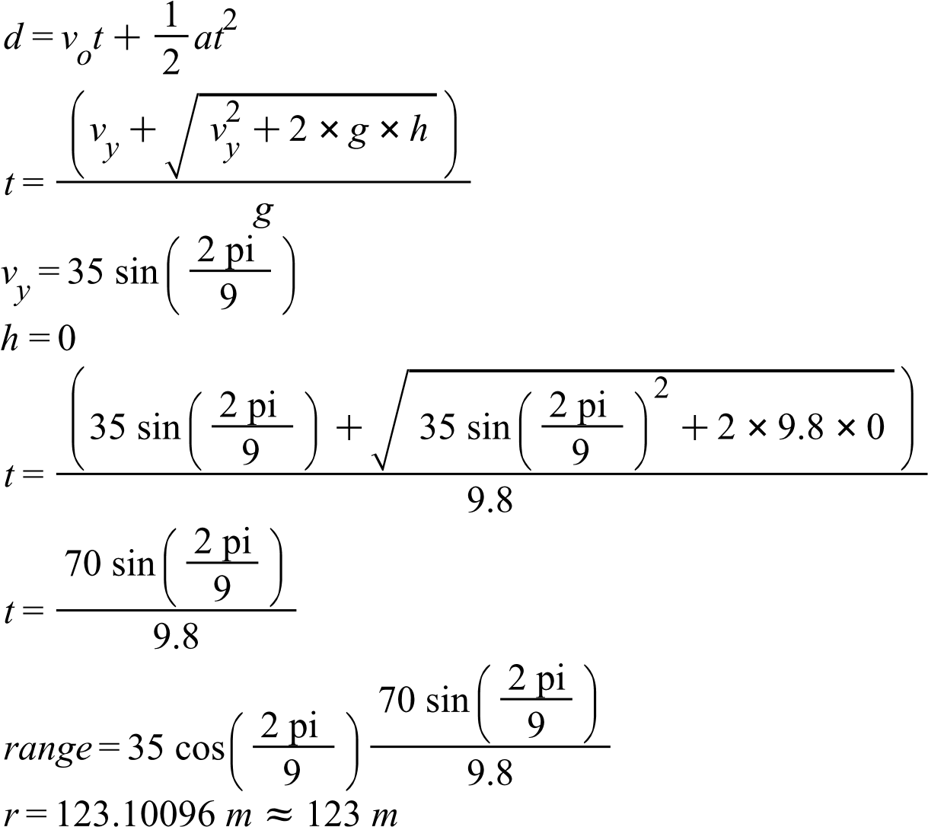

- A golf ball is struck and leaves the ground at 48 m/s on a 60degree angle.
  - How long will it be in the air before bouncing?

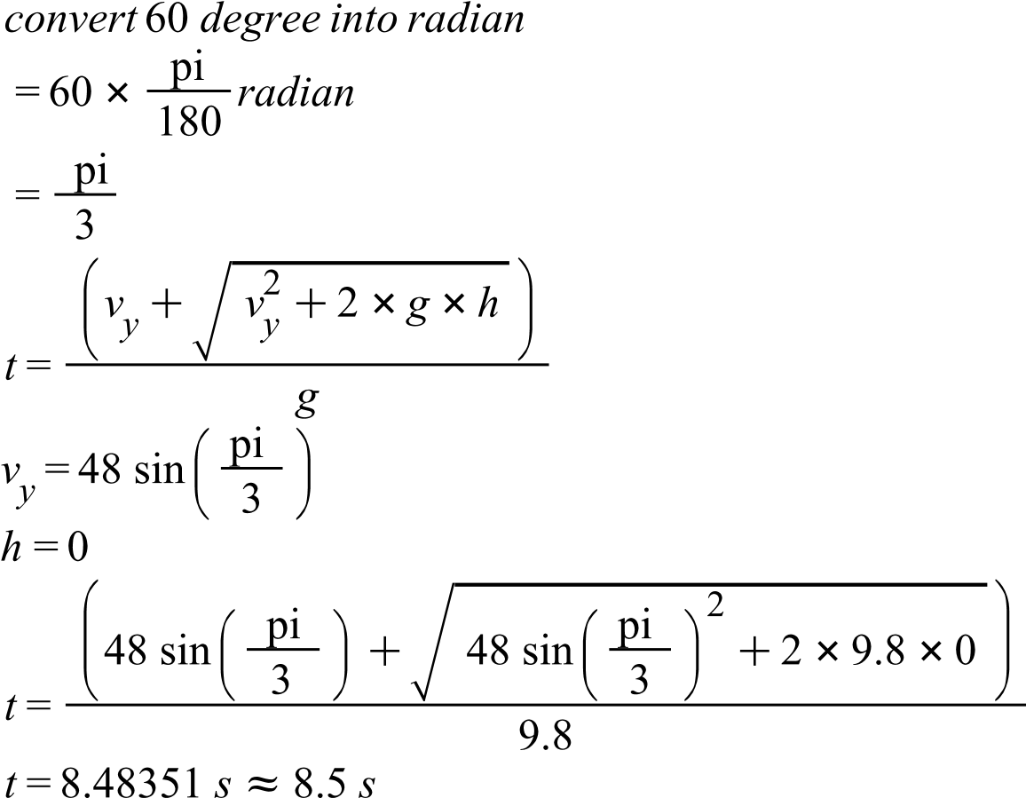

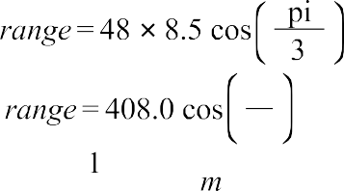
  - How far will the ball in the previous example travel in the air before the first bounce?
= 204
  - Determine the velocity of the ball 2 seconds after it was struck.

  - The most common incorrect answer for this question is 22m/s. What has actually been calculated if this is the answer?

- A football is kicked off at 40 degrees to the field at a velocity of 24 m/s. What is the range of this kick?

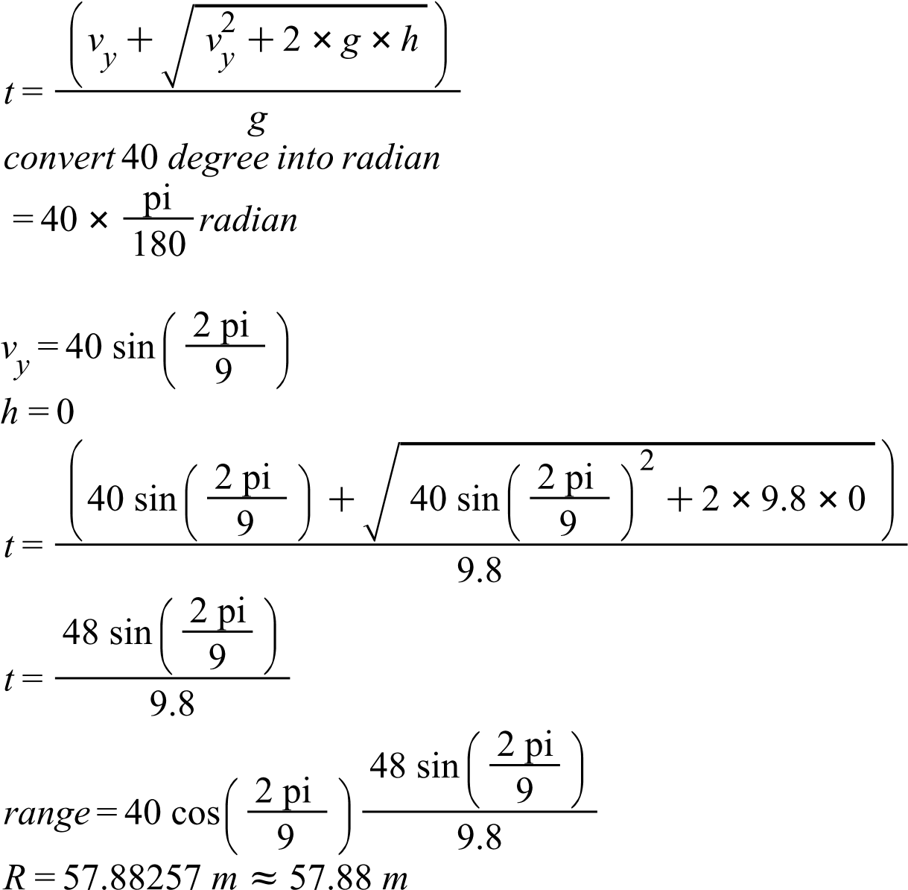

- What is the maximum height of a rock launched by a sling shot at 50 m/s on an angle of 80 degrees?

- A soccer player kicks a ball from ground level at 27 m/s at an angle of 30 degrees above the horizontal.
- What is the "hang time" (time in the air) of the ball? Show all work as done in lessons.
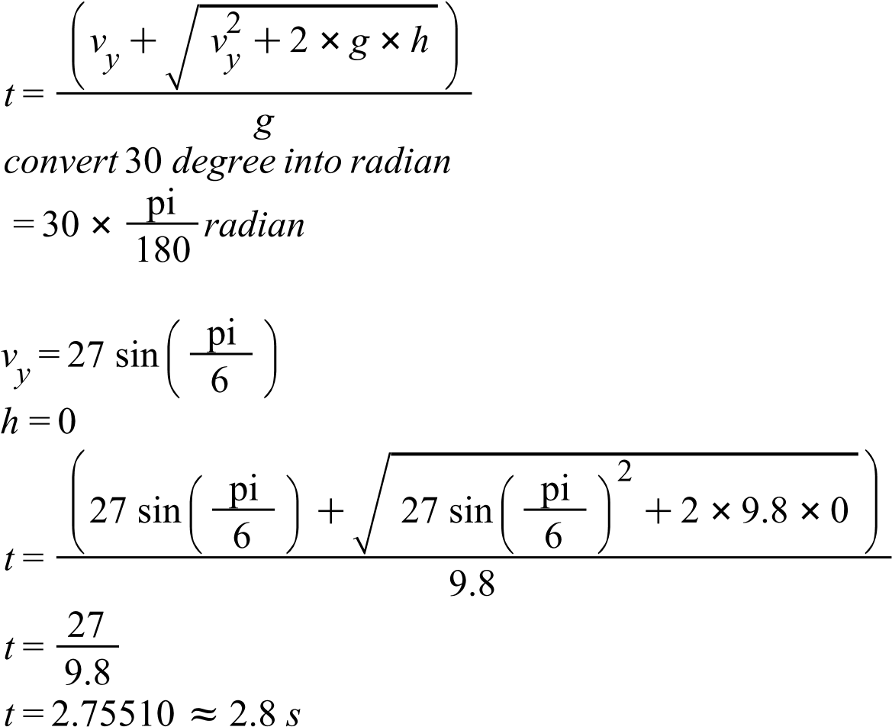
- How far does the ball travel before hitting the ground? Show all work as done in lessons
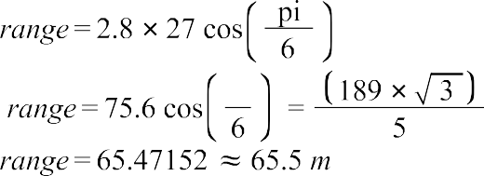
- A grade 12 Physics student shoots a basketball from the ground at a hoop which is 2.0 m above her release. The shot was at a velocity of 15 m/s and at an angle of 70 degrees to the ground. What was the distance to the hoop if the shot was good? Note: components have been found for the initial velocity.
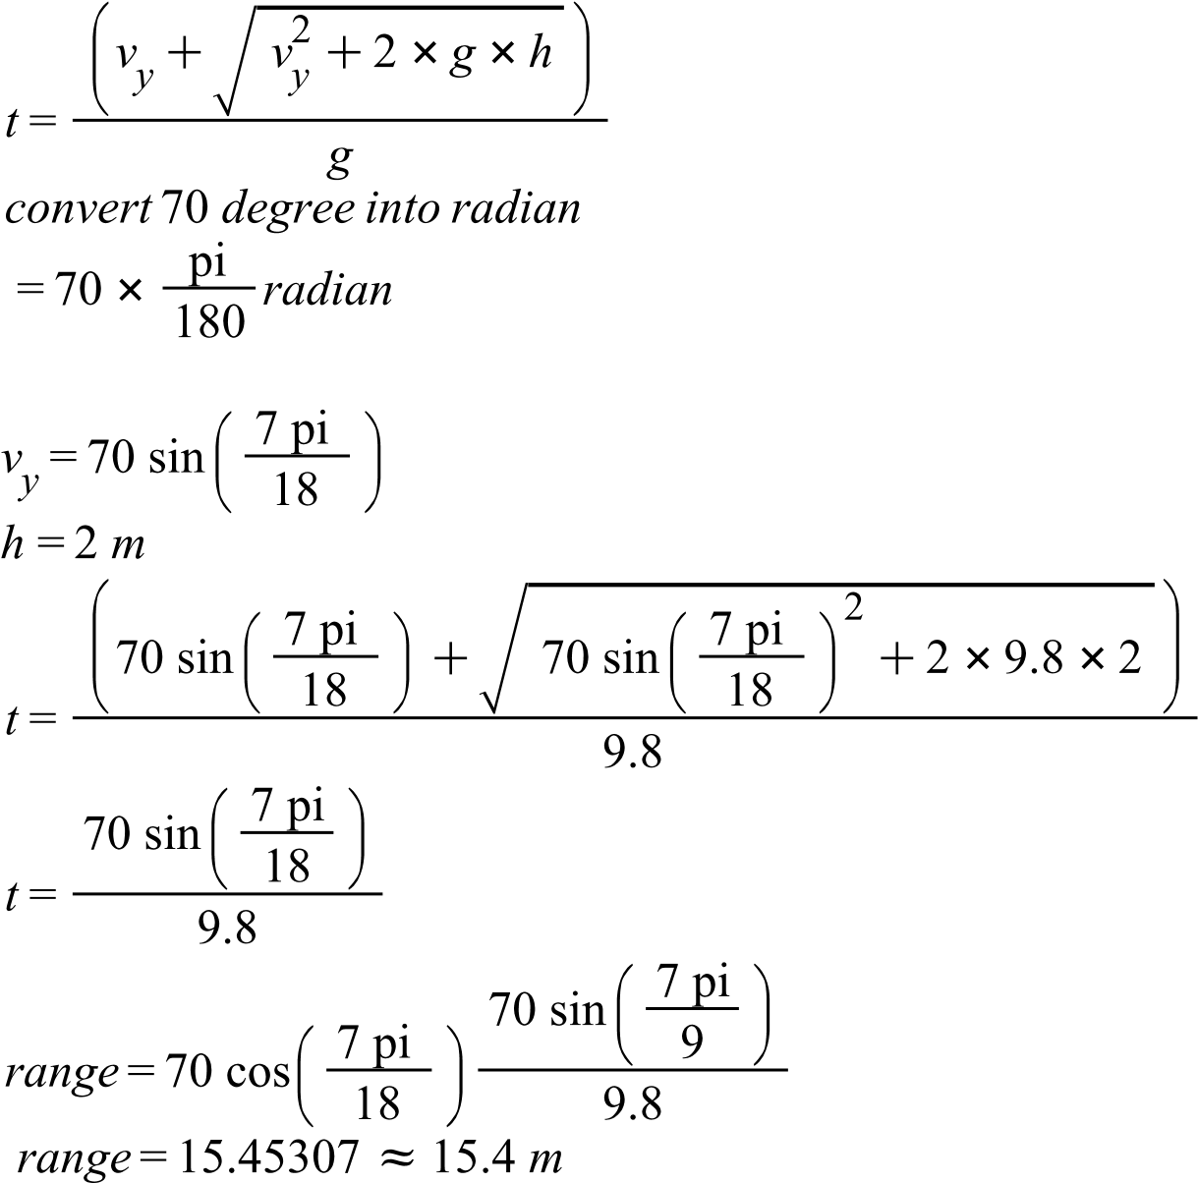
- Find the range for a basketball thrown at 6.0 m/s at an angle of 50° above the horizon if it leaves from a height of 2.0m.
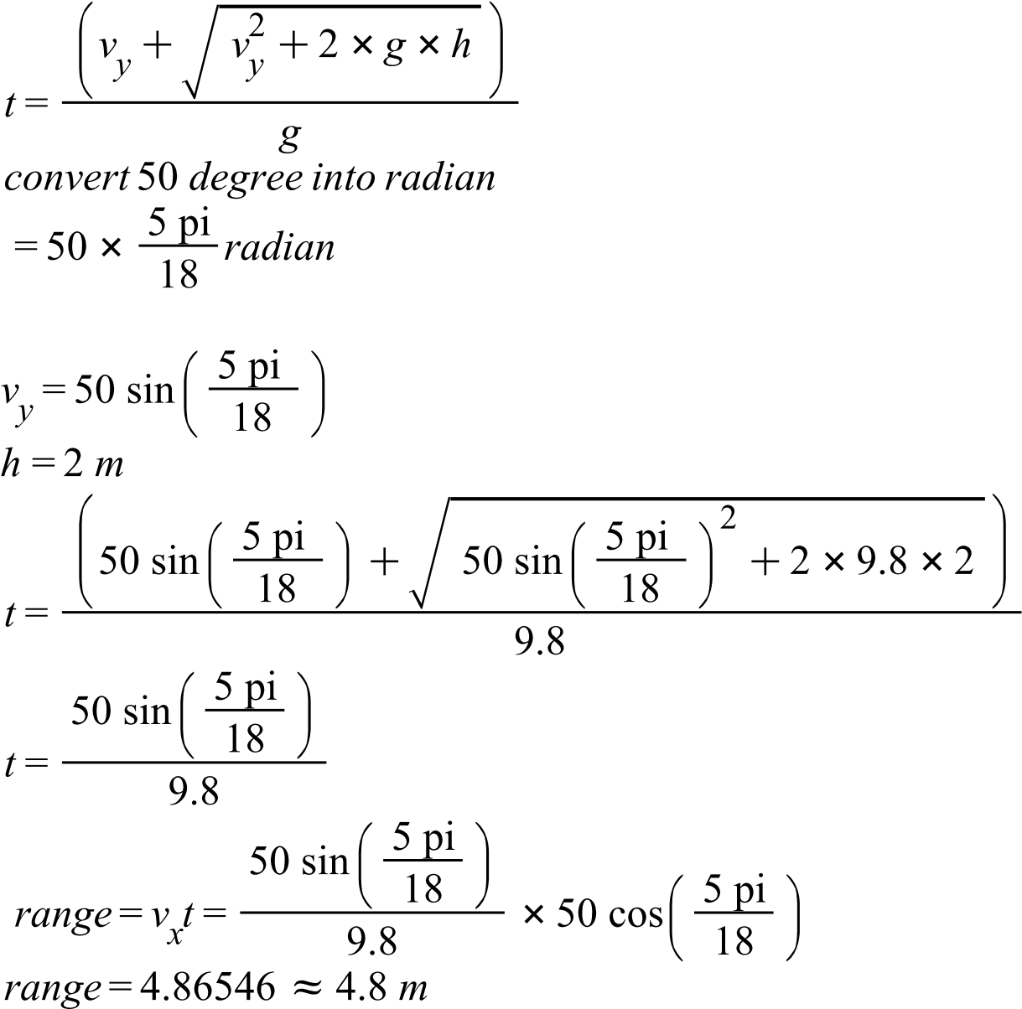
- Calculate the range of a rock thrown from the top of a 30 m high cliff. The rock is thrown at 8.0 m/s at 30 degrees down from the horizontal.

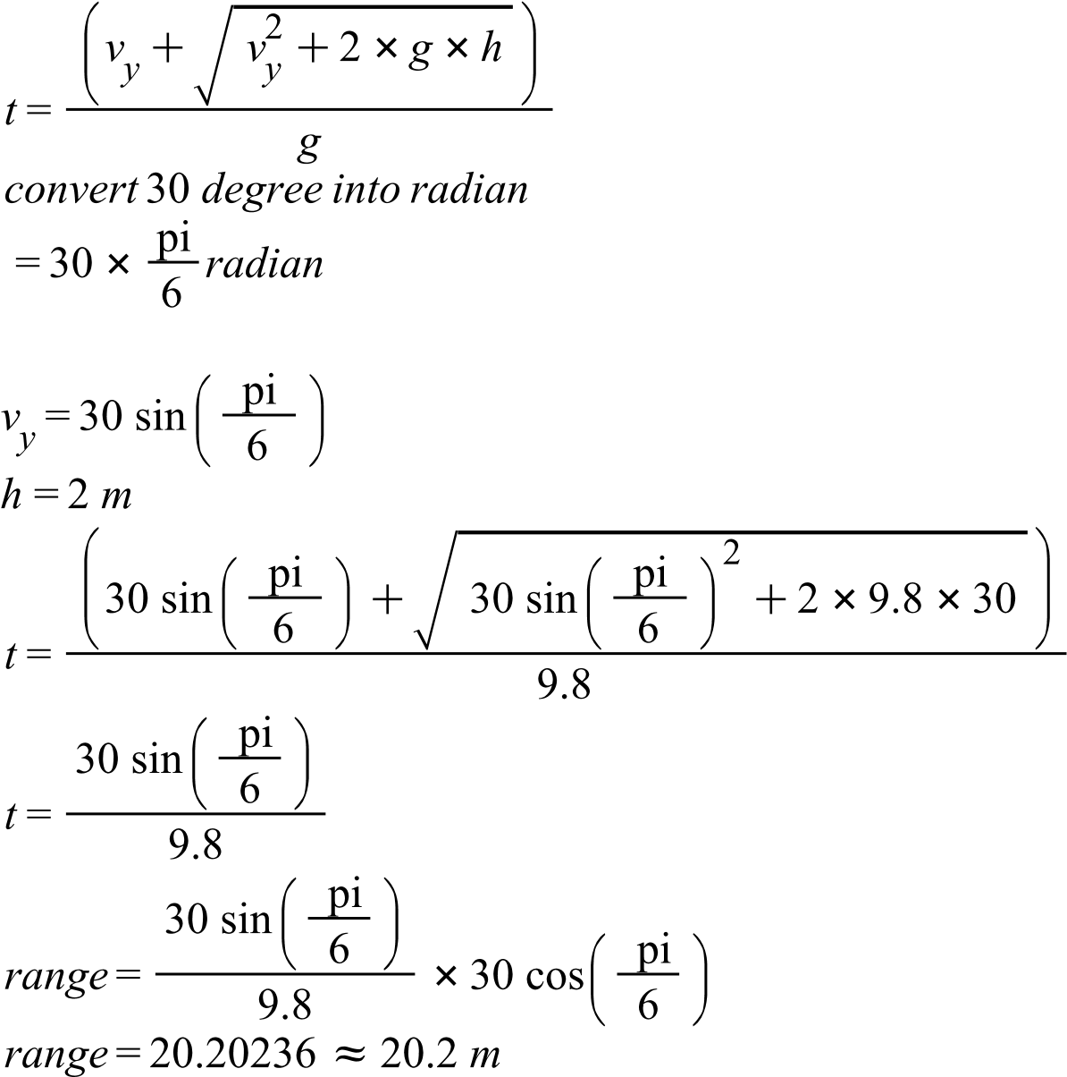

- During the filming of a TV show, a stuntman runs horizontally off the edge of the roof of a
building 49 m high, with a horizontal velocity of 3.6 m/s.
a. For how many seconds will the falling stuntman be in the air?
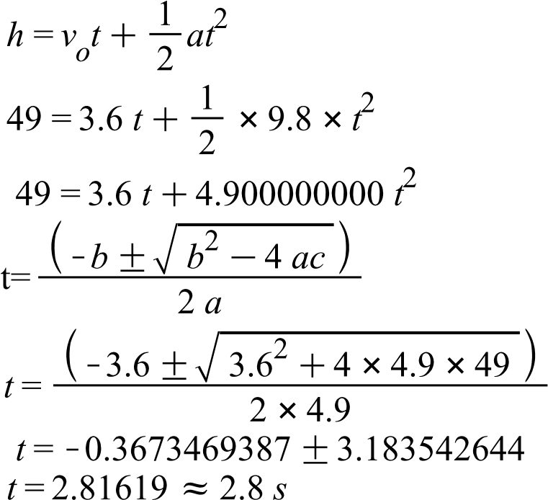

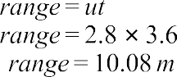
- How far out from the edge of the building should the safety bag be placed so that he can fall without being hurt?
- What is the maximum distance a baseball pitcher could throw a ball on the moon, if he throws it with a velocity of 36.0 m/s at an angle of 45.0° above the horizontal? (g = -1.6 m/s)
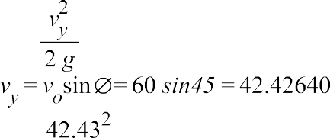

- A grade 12 Physics student shoots a basketball from the ground at a hoop which is 2.0 m above her release. The shot was at a velocity of 10 m/s and at an angle of 80° to the ground.
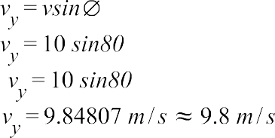
  - Determine the vertical velocity of the ball when it is at the level of the net. You should get two answers.
  - Using your answer to (a) determine the time of flight for the ball (from release to basket).
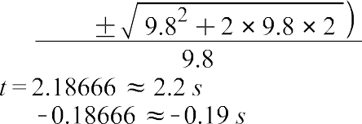
  - When solving projectiles, you will often get two possible times for solutions. Sometimes a time will be negative and can be rejected. Other times both times will be positive and therefore possible. Explain why both times above make sense in the context of the given information used. Which time will you ultimately choose and why? Use the diagram to label where the rock is at the two times found above. Label the heights at these points with a dotted, horizontal line.
The time that t>0 implies the time that occurs after the projectile motion while the time t<0 refers to the time before the projectile motion takes place. Both time are sensible since there is occurrence of time both before or after the projectile motion. However, I would choose the time t>0 since the focus is on the time spent by the projectile before it hits the ground.

